PRECALCULUS
SOLUTIONS
Question Two
Verify that f and g are inverse functions algebraically
$f\left(x\right)=\frac{x-4}{7}$, $g\left(x\right)=7x+4$
solution
Given that
$f\left(x\right)=\frac{x-4}{7}$, $g\left(x\right)=7x+4$
$⟹f\left(g\left(x\right)\right)=f\left(7x+4\right)$
Finally;
$f\left(7x+4\right)=\frac{\left(7x+4\right)-4}{7}=\frac{7x+4-4}{7}=\frac{7x}{7}=x$

$g\left(f\left(x\right)\right)=g\left(\frac{x-4}{7}\right)$
$⟹g\left(\frac{x-4}{7}\right)=7\left(\frac{x-4}{7}\right)+4=x-4+4=x$

Question 3
For each function, sketch the graphs of the function when $c=-6, -2, 1and 2$ on the same set of coordinate axes
- $f\left(x\right)=f\left(x\right)=\left\{\begin{aligned}x^{2}+c, &x<0 \\ -x^{2}+c, &x≥0\end{aligned}\right.$
Solution
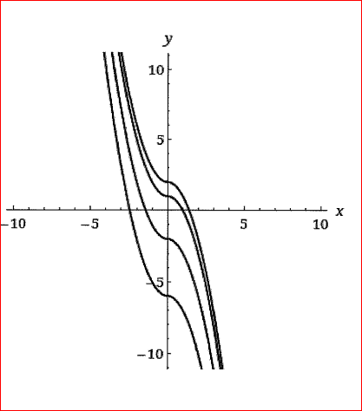
- $f\left(x\right)=\left\{\begin{aligned}{\left(x+c\right)}^{2}, &x<0 \\ {-\left(x+c\right)}^{2}, &x≥0\end{aligned}\right.$
SOLUTION
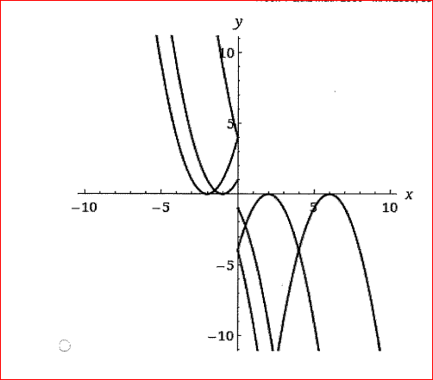
QUESTION 4
Determine whether the equation represents y as a function of x
$x^{2}-y=81$
Solution
$x^{2}-y=81⇔y=x^{2}-81$
Thus, our solution is yes.
QUESTION 5
Does the function have an inverse function?
Solution
x | -5 | -4 | -3 | 1 | 2 | 3
F(x) | 6 | 5 | 3 | -1 | -7 | -8

Since each value of y that is $f(x)$ is unique for each input value of x, then our function is one-to-one function and therefore, has an inverse
Hence, yes

QUESTION 6
Use the graph of the function to find the domain and range of f. (Enter your answer using interval notation)
$Domain:(-∞,∞)$
$Range:(-∞, ∞)$

Use the graph to find the indicated function values
- $f\left(-1\right)=4$
- $f\left(1\right)=6$
- $f\left(2\right)=7$
QUSTION 7
Find the following.
$f\left(x\right)=5x-9, g\left(x\right)=4-x$
- $\left(f+g\right)\left(x\right)$
SOLUTION
$⇒\left(f+g\right)\left(x\right)=\left(5x-9\right)+\left(4-x\right)=5x-9+4-x$
$⇒\left(f+g\right)\left(x\right)=5x-x-9+4=4x-5$
$∴\left(f+g\right)\left(x\right)=4x-5$
- $\left(f-g\right)\left(x\right)$
SOLUTION
$⇒\left(f-g\right)\left(x\right)=\left(5x-9\right)-\left(4-x\right)=5x-9-4+x$
$⇒\left(f-g\right)\left(x\right)=5x+x-9-4=6x-13$
$⇒\left(f-g\right)\left(x\right)=6x-13$
- $(fg)(x)$
SOLUTION
$⇒\left(fg\right)\left(x\right)=\left(5x-9\right)\left(4-x\right)=5x\left(4-x\right)-9(4-x)$
$⇒\left(fg\right)\left(x\right)=20x-5x^{2}-36+9x$
$⇒\left(fg\right)\left(x\right)=20x+9x-5x^{2}-36$
$⇒\left(fg\right)\left(x\right)=29x-5x^{2}-36$

- $\left(\frac{f}{g}\right)\left(x\right)$
SOLUTION
$⇒\left(\frac{f}{g}\right)\left(x\right)=\frac{5x-9}{4-x}$
- What is the domain of $\frac{f}{g}?(Enter your answer using interval notation)$
SOLUTION
$Domain=\left(-∞,4\right)U(4,∞)$

QUESTION 8
Consider the following graph
- The parent function;
SOLUTION
$⇒y=\frac{1}{x}$
- Identify the transformation represented by the graph
SOLUTION
Vertical stretch
Equation for the function represented by the graph.
$y=\frac{5}{x+1}+2$

QUESTION 9
Evaluate the function for $f\left(x\right)=x+3$ and $g\left(x\right)=x^{2}-2$
$\left(\frac{f}{g}\right)\left(2\right)$
SOLUTION
$⇒\left(\frac{f}{g}\right)=\frac{x+3}{x^{2}-2}$
$⇒\left(\frac{f}{g}\right)\left(2\right)=\frac{2+3}{{\left(2\right)}^{2}-2}=\frac{5}{4-2}=\frac{5}{2}=2.5$

Question 10
Finding the zeros
$f\left(x\right)=\frac{x^{2}-10x+21}{5x}$
SOLUTION
$x=3, 7$

